Nama : Jefri Haris Laksmana  
NIM : 18090025  
Kelas : 5D

Praktikum 1

1. Source Code  
   perkenalan.php -> application/controllers/

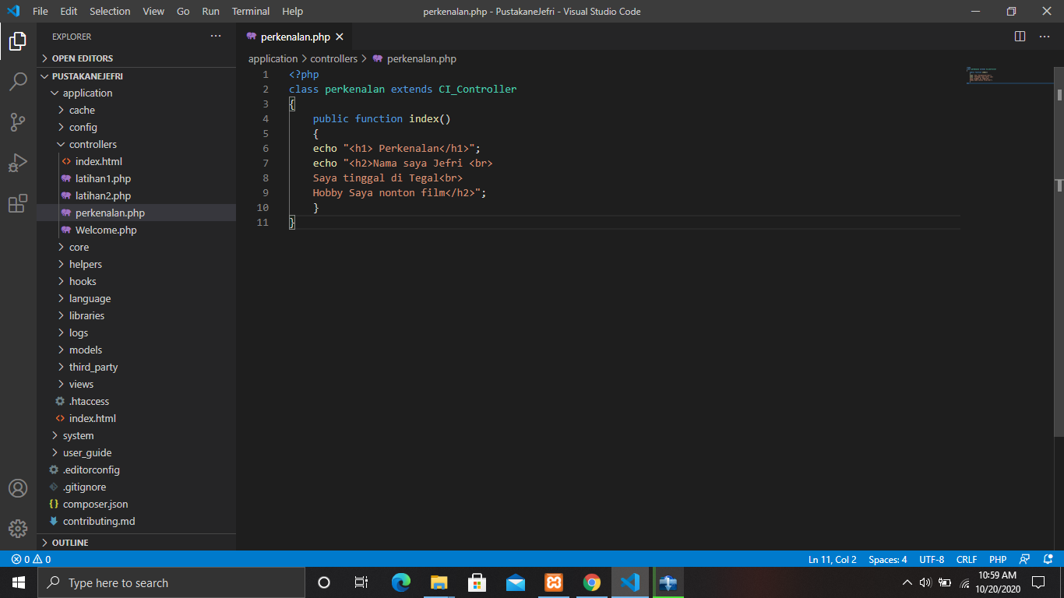

1. URL  
   <http://localhost/PustakaneJefri/index.php/perkenalan>
2. Capture Output Program  
   